In [21]:
import cv2
import matplotlib.pyplot as plt

In [22]:
image = cv2.imread("../data/Q1.png") plt.figure(figsize=(10, 10))
plt.title("Original Image") plt.imshow(image)

Out[22]:

In [23]:

Out[23]:
<matplotlib.image.AxesImage at 0x267cf45f9d0>
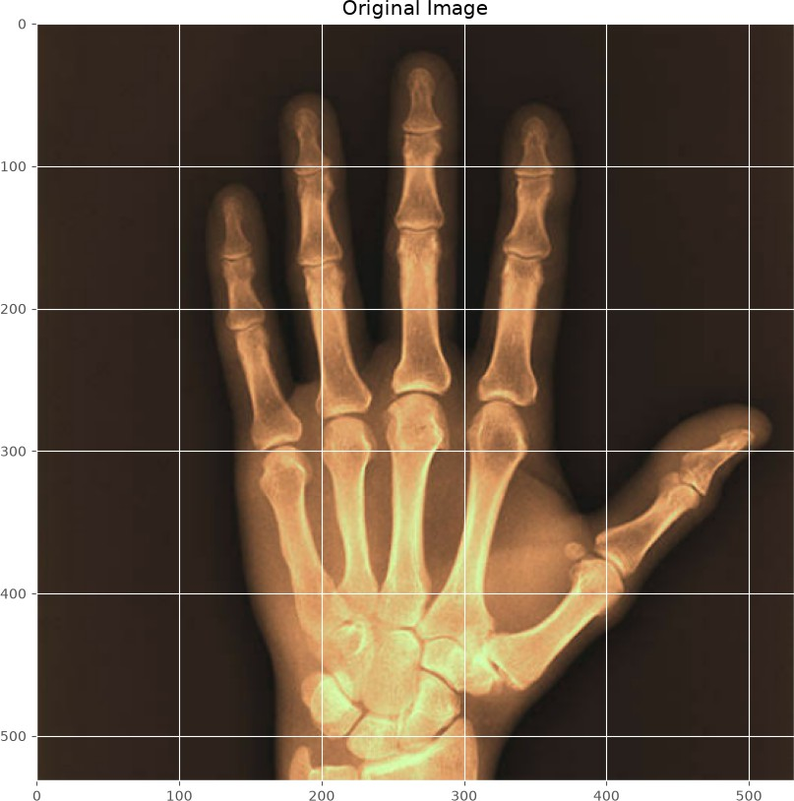
gray_image = cv2.cvtColor(image, cv2.COLOR_BGR2GRAY) plt.figure(figsize=(10, 10))
plt.title("Gray Image")
plt.imshow(gray_image, cmap="gray")

<matplotlib.image.AxesImage at 0x267cf4f1810>

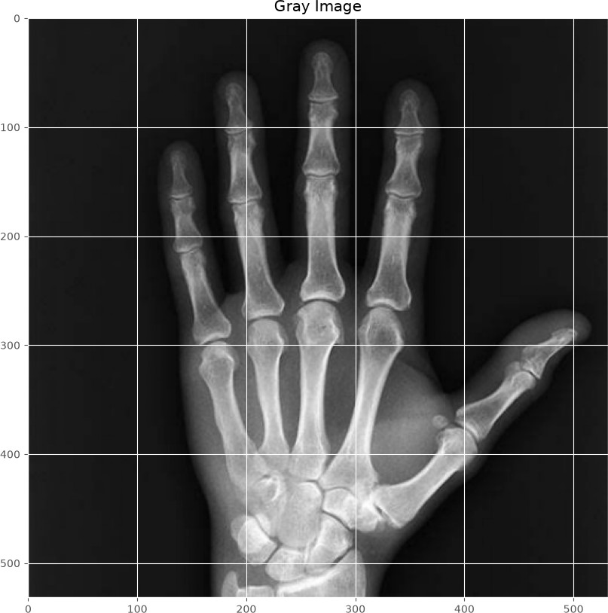

In [24]:
resize_image = cv2.resize(gray_image, (224, 224))
plt.figure(figsize=(10, 10)) plt.title("Resize image")
plt.imshow(resize_image, cmap="gray")

Out[24]: <matplotlib.image.AxesImage at 0x267cfa9f610>

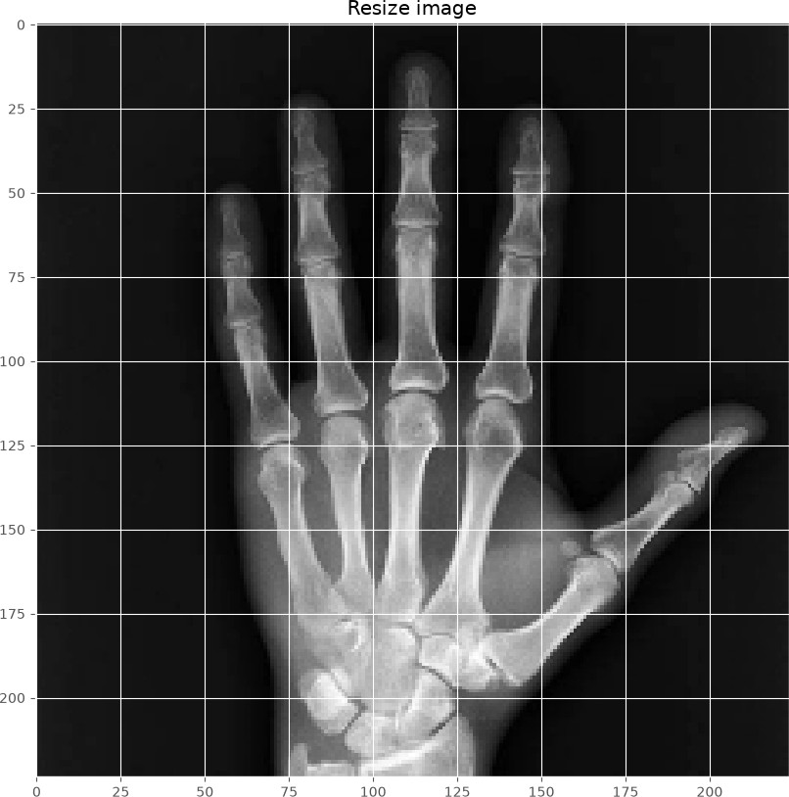

In [25]:
canny_edge_image = cv2.Canny(resize_image, 100, 200)
plt.figure(figsize=(10, 10)) plt.title("Canny Image")
plt.imshow(canny_edge_image, cmap="gray")

Out[25]: <matplotlib.image.AxesImage at 0x267cfb54190>

